**Course Methods Year 11**

Student name: ________________________ Teacher name: ________________

Date: 17/02/20

**Task type: Response**

**Time allowed for this task: 40 mins**

**Number of questions: 6**

**Materials required:** NO CALCULATOR REQUIRED

NO NOTES REQUIRED

Standard items: Pens (blue/black preferred), pencils (including coloured), sharpener, correction fluid/tape, eraser, ruler, highlighters

Special items: Drawing instruments, templates and formula sheet

**Marks available: 37 marks**

**Task weighting: 10 %**

**Formula sheet provided: Yes**

**Note: All part questions worth more than 2 marks require working to obtain full marks.**

**Question 1 (1.1.6) (2, 2 = 4 marks)**

Solve each of the following for $x$*.*

$2x-3=11-5x$

$$-3x = 14$$

$$x = -\frac{14}{3}$$

$10-2x=\frac{2x}{3}$

$$8x=30$$

$$x=\frac{30}{8}$$

**Question 2 (1.1.4, 11.5, 1.1.6) (2, 3, 2, 3 = 10 marks)**

Determine the equation of a line that passes through the point $(-4, 6)$ and:

1. has a gradient of 3
$$y = 3x + c$$

$$c=-(3\left(-4\right)-6)$$

$$y = 3x + 18$$

2. passes through the point $\left(2, 5\right).$
$$m=\frac{rise}{run}$$

$$m= \frac{-1}{6}$$

$$y=-\frac{1}{6}x+c$$

$$c= -(\frac{1}{6}\left(2\right)-5)$$

$$y=-\frac{1}{6}x+\frac{16}{3}$$

3. is parallel to the line $2y-4x=-7$.
$$2y-4x=-7→y=2x-\frac{7}{2}$$

$$y= -\frac{1}{2}x+c$$

$$c= -(-\frac{1}{2}\left(-4\right)-6)$$

$$y= -\frac{1}{2}x+4$$

4. is perpendicular to the line $2y-x-8=0.$

$$2y-x-8=0→y=\frac{x}{2}+4$$

$$y=-2x+c$$

$$c=-(-2\left(-4\right)-6)$$

$$y=-2x-2$$

**Question 3 (1.1.1, 1.1.5, 1.1.6) (3, 2, 2 = 7 marks)**

The coordinates $P(2,p)$ and $Q(q+1, 3q-2)$ both lie on the line $y=5x+1$.

1. Find:
2. the values of $p$ and $q$.

p = 5(2) + 1

p = 11

3q – 2 = 5(q + 1) + 1

3q = 5q + 8

q = 4

**p = 11, q = 4**

1. the midpoint of $PQ$.

(2, 11), (4 + 1, 3(4) – 2) 🡪 (2, 11), (5, 10)

5 – 2 = 3, 10 – 11 = -1

3/2 = 1.5, -1/2 = -0.5

2 + 1.5 = 3.5, 11 + -0.5 = 10.5

**(3.5, 10.5)**

1. For what value of $m$ does the line $y=mx+2$ not intersect with the line $y=5x+1$? Justify your answer.

m = 5

Two lines must be parallel with different y intercepts in order to not intersect. Therefore, m must equal 5 as the gradient of the other line is also 5.

**Question 4 (1.1.4, 1.1.5) (2, 1, 1, 2, 1 = 7 marks)**

The graph below shows cost, $C$, in dollars versus distance $x$, in kilometres, for two different car rental companies A and B. (Assume that parts of distance are charged for proportionately.)

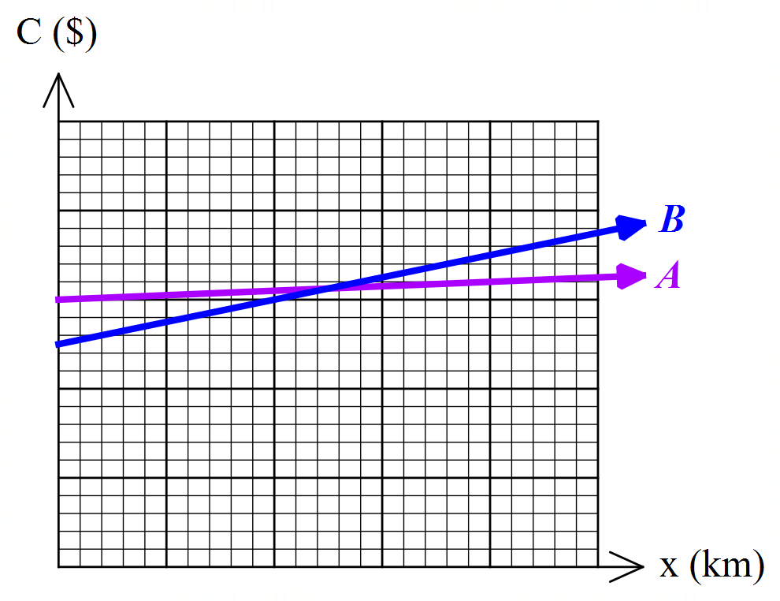

The costs for each company are outlined in the table below.

1. Which cost equation corresponds to Company A and Company B?

|  |  |
| --- | --- |
| $$C=250+0.25x$$ | $$C=300+0.05x$$ |
| Company B | Company A |

1. Explain what the gradient in the equation $C=250+0.25x$ represents.

For every kilometre travelled, the cost increases by $0.25.

1. Construct a linear rule for $y=C_{A}-C_{B}$, the difference in cost between Company $A$ and Company $B$.

$y =50-0.20x$

1. Sketch the equation from part c) on the graph below clearly showing all intercepts.

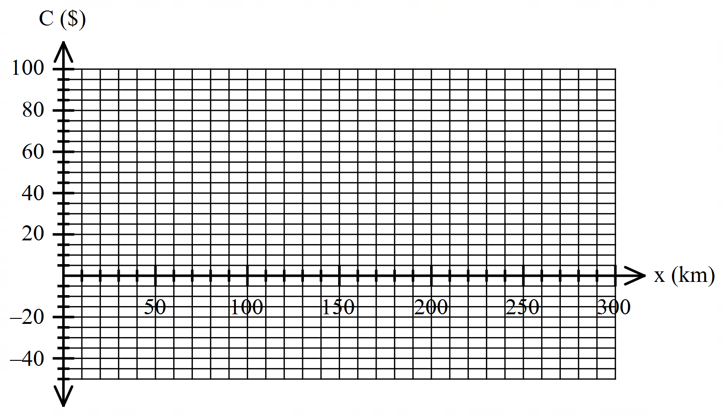

1. Using the graph in part d) determine the number of km when the costs of Company $A$ is cheaper than those of Company $B$.

x > 250km

**Question 5 (1.1.6) (5 marks)**

Solve for $x$, expressing your answer in its simplest form in terms of $a$ and/or $b$.

$\frac{x+a}{b}=\frac{b-x}{a}$ [$a$, $b≠0$]

$ax+a^{2} = b^{2}-bx$

$$ax+bx=b^{2}-a^{2}$$

$$x\left(a+b\right)=b^{2}-a^{2}$$

$$x=\frac{b^{2}-a^{2}}{a+b}$$

$$x=\frac{(b-a)(a+b)}{a+b}$$

$$x=b-a, a+b≠0$$

**Question 6 (1.1.6) (2, 1, 1 = 4 marks)**

A car travelling at $60 km/h$ takes $t$ hours to go from $A$ to $B$. If the speed of the car is reduced by $10 km/h$, the time to go from $A$ to $B$ is increased by half an hour.

1. Construct a linear equation for $t$ using the information given.

k = 60 * t

k = 50 * (t + 0.5)

1. Solve your equation in part a) and hence calculate the value of $t$.

k = 50 * (t + 0.5)

k = 25 + 50t

60t = 50t + 25

10t = 25

t = 2.5

1. Find the distance between $A$ and $B$.

k = 60km/h * 2.5h

k = 150km

**END OF TEST**